







React native apk 打包

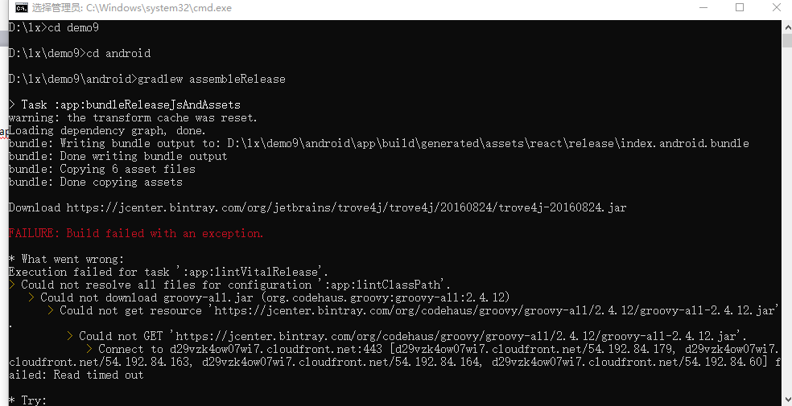

报错，解决方案：

AILURE: Build failed with an exception.

* What went wrong:

Execution failed for task ':app:lintVitalRelease

解决方案：

<https://blog.csdn.net/swallow_csdn/article/details/83012642>

打包时的错误提示：

Error:Execution failed for task ':app:lintVitalRelease'. > java.lang.IllegalStateException: Expected a name but was STRING at line 1 column 99 path $[0].apkInfo.versionName

debug版可以运行，release版生成不了。似乎是有没有用到的module,只需在app下的gradle文件的android部分添加代码：

lintOptions {

checkReleaseBuilds false

abortOnError false

Android/app/build.gradle文件

apply plugin: "com.android.application"

import com.android.build.OutputFile

/**

* The react.gradle file registers a task for each build variant (e.g. bundleDebugJsAndAssets

* and bundleReleaseJsAndAssets).

* These basically call `react-native bundle` with the correct arguments during the Android build

* cycle. By default, bundleDebugJsAndAssets is skipped, as in debug/dev mode we prefer to load the

* bundle directly from the development server. Below you can see all the possible configurations

* and their defaults. If you decide to add a configuration block, make sure to add it before the

* `apply from: "../../node_modules/react-native/react.gradle"` line.

*

* project.ext.react = [

* // the name of the generated asset file containing your JS bundle

* bundleAssetName: "index.android.bundle",

*

* // the entry file for bundle generation

* entryFile: "index.android.js",

*

* // whether to bundle JS and assets in debug mode

* bundleInDebug: false,

*

* // whether to bundle JS and assets in release mode

* bundleInRelease: true,

*

* // whether to bundle JS and assets in another build variant (if configured).

* // See http://tools.android.com/tech-docs/new-build-system/user-guide#TOC-Build-Variants

* // The configuration property can be in the following formats

* // 'bundleIn${productFlavor}${buildType}'

* // 'bundleIn${buildType}'

* // bundleInFreeDebug: true,

* // bundleInPaidRelease: true,

* // bundleInBeta: true,

*

* // whether to disable dev mode in custom build variants (by default only disabled in release)

* // for example: to disable dev mode in the staging build type (if configured)

* devDisabledInStaging: true,

* // The configuration property can be in the following formats

* // 'devDisabledIn${productFlavor}${buildType}'

* // 'devDisabledIn${buildType}'

*

* // the root of your project, i.e. where "package.json" lives

* root: "../../",

*

* // where to put the JS bundle asset in debug mode

* jsBundleDirDebug: "$buildDir/intermediates/assets/debug",

*

* // where to put the JS bundle asset in release mode

* jsBundleDirRelease: "$buildDir/intermediates/assets/release",

*

* // where to put drawable resources / React Native assets, e.g. the ones you use via

* // require('./image.png')), in debug mode

* resourcesDirDebug: "$buildDir/intermediates/res/merged/debug",

*

* // where to put drawable resources / React Native assets, e.g. the ones you use via

* // require('./image.png')), in release mode

* resourcesDirRelease: "$buildDir/intermediates/res/merged/release",

*

* // by default the gradle tasks are skipped if none of the JS files or assets change; this means

* // that we don't look at files in android/ or ios/ to determine whether the tasks are up to

* // date; if you have any other folders that you want to ignore for performance reasons (gradle

* // indexes the entire tree), add them here. Alternatively, if you have JS files in android/

* // for example, you might want to remove it from here.

* inputExcludes: ["android/**", "ios/**"],

*

* // override which node gets called and with what additional arguments

* nodeExecutableAndArgs: ["node"],

*

* // supply additional arguments to the packager

* extraPackagerArgs: []

* ]

*/

project.ext.react = [

entryFile: "index.js"

]

apply from: "../../node_modules/react-native/react.gradle"

/**

* Set this to true to create two separate APKs instead of one:

* - An APK that only works on ARM devices

* - An APK that only works on x86 devices

* The advantage is the size of the APK is reduced by about 4MB.

* Upload all the APKs to the Play Store and people will download

* the correct one based on the CPU architecture of their device.

*/

def enableSeparateBuildPerCPUArchitecture = false

/**

* Run Proguard to shrink the Java bytecode in release builds.

*/

def enableProguardInReleaseBuilds = false

android {

compileSdkVersion rootProject.ext.compileSdkVersion

buildToolsVersion rootProject.ext.buildToolsVersion

defaultConfig {

applicationId "com.demo9"

minSdkVersion rootProject.ext.minSdkVersion

targetSdkVersion rootProject.ext.targetSdkVersion

versionCode 1

versionName "1.0"

ndk {

abiFilters "armeabi-v7a", "x86"

}

}

signingConfigs {

release {

storeFile file("D:/lx/demo9/android/app/my-release-key.keystore")

storePassword "123456"

keyAlias "my-key-alias"

keyPassword "123456"

}

}

splits {

abi {

reset()

enable enableSeparateBuildPerCPUArchitecture

universalApk false // If true, also generate a universal APK

include "armeabi-v7a", "x86"

}

}

buildTypes {

release {

minifyEnabled enableProguardInReleaseBuilds

proguardFiles getDefaultProguardFile("proguard-android.txt"), "proguard-rules.pro"

signingConfig signingConfigs.release

}

}

// applicationVariants are e.g. debug, release

applicationVariants.all { variant ->

variant.outputs.each { output ->

// For each separate APK per architecture, set a unique version code as described here:

// http://tools.android.com/tech-docs/new-build-system/user-guide/apk-splits

def versionCodes = ["armeabi-v7a":1, "x86":2]

def abi = output.getFilter(OutputFile.ABI)

if (abi != null) { // null for the universal-debug, universal-release variants

output.versionCodeOverride =

versionCodes.get(abi) * 1048576 + defaultConfig.versionCode

}

}

}

lintOptions {

checkReleaseBuilds false

abortOnError false

}

}

dependencies {

implementation fileTree(dir: "libs", include: ["*.jar"])

implementation "com.android.support:appcompat-v7:${rootProject.ext.supportLibVersion}"

implementation "com.facebook.react:react-native:+" // From node_modules

}

// Run this once to be able to run the application with BUCK

// puts all compile dependencies into folder libs for BUCK to use

task copyDownloadableDepsToLibs(type: Copy) {

from configurations.compile

into 'libs'

}





